# Task C10.2.2

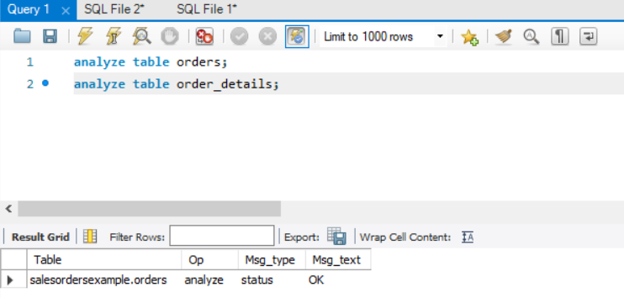

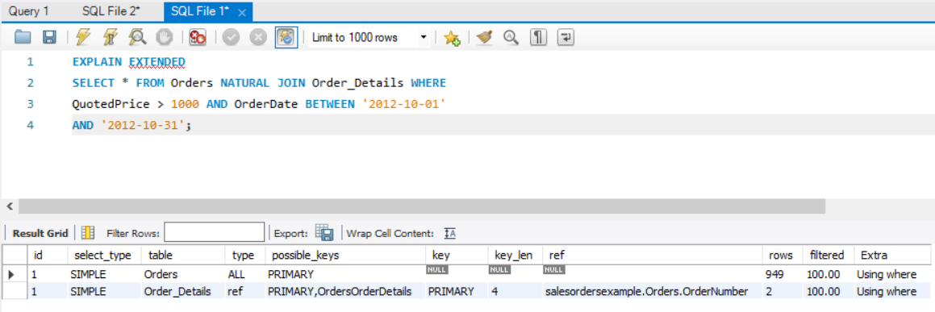

f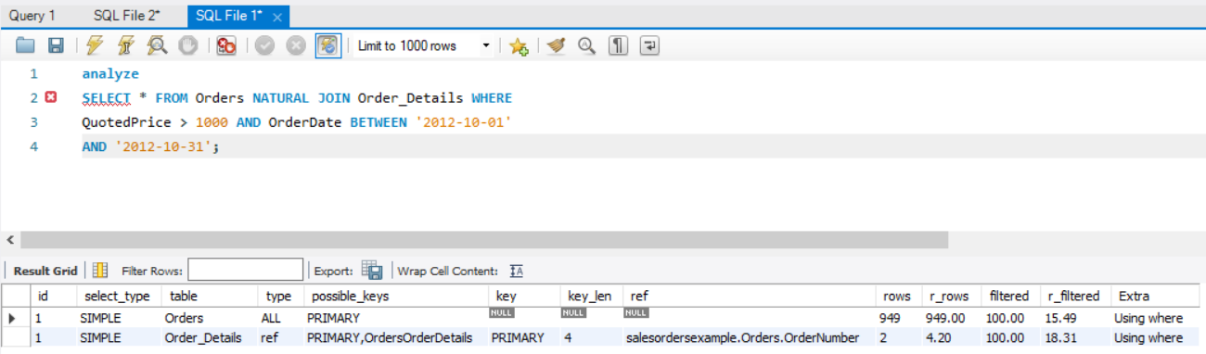

ANALYZE basically performs particular type of analysis on given table called key distribution analysis.

Analyze brings table from database and puts it on flush lock until process gets finished. It performs statistics on table to make it stable and precise to perform operations.

ANALYZE TABLE is used to optimize index cardinality estimation in join operation of MySQL table.